Charlie Nitschelm  
Satellites  
02/05/2020

The Most-Traveled Satellite, Voyager 1

Our knowledge of the other planets in our solar system in the 1950’s was limited to the power of our ground telescopes and instruments. Once the space race began and the ability to put satellites into orbit became possible, it was proposed in the 1960’s to create a probe to not just leave earth and orbit, but travel to the other planetary bodies to study and venture further into space then ever thought possible. Voyager 1, launched on September 5, 1977, was the second of twin satellites dedicated to this exploration mission (Voyager 1). Voyager 2 was launched a couple of week before Voyager 1 with a different route, ultimately gaining less overall speed from planet gravity assists. The outer solar system at the time was the least known, consisting of the super giants Jupiter, Saturn, Uranus, Neptune and Pluto. Voyager 1 was the first man-made object to reach the edge of the solar system and is still the furthest man-made object in human history.

The primary instrument and most notable when viewed in pictures is the communication system. It features a 3.7 meter diameter high gain Cassegrain antenna designed to enable communication with earth well beyond the edge of the solar system (Voyager 1). It sends and receives radio waves via the three Depp Space Network stations on the Earth. It currently takes over 20 hours to communicate with Voyager 1 as of this writing for that is how long signals need to take to reach. The power of the satellite is supplied by a thermoelectric generator mounted on a large boom. It contains 24 plutonium-238 oxide spheres and supplies the satellite with a constant 470W of power for its instruments and computer systems (Voyager 1). To keep the satellite oriented in the right direction, which is keeping the primary antenna pointed at Earth, the Attitude and Articulation Control Subsystem (AACS) is used (Howell). It has been very reliable.

The primary fly-bys that were planned into Voyager 1’s mission was Jupiter, Saturn and Saturn’s largest moon Titan. It was very close to not going near Titan to include Pluto as the last stop for it trajectory, but it was voted to study Titan instead of Pluto as it was more interesting to scientists at NASA and JPL for its atmospheric conditions (Voyager 1). During the Jupiter flyby, notable videos and beautiful pictures were transmitted back, bringing the environment there much closer to home. Europa and Io were primary moons pictures, some seen closer than 100 miles from their surface (Howell). A beautiful eruption plume from Io was pictured during the pass-by, seen below.

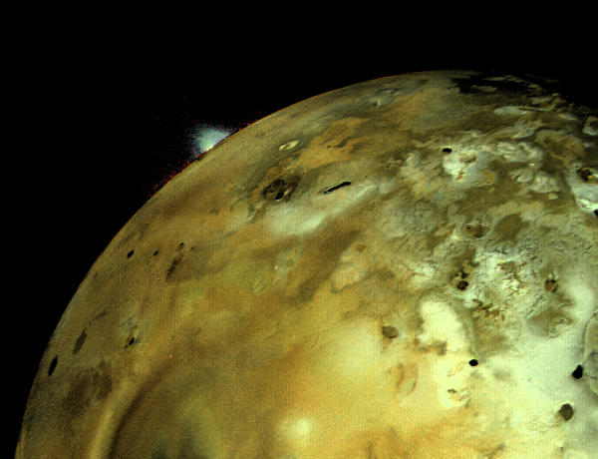

Figure - An image from Voyager 1 on Saturn’s moon Io

During the Saturn fly-by, which occurred in November 1980, with the closest pass by happening on November 12, 1980 just 77,000 miles from its surface, gave us the most in-depth look of the planet ever before recorded. A notable picture that was produced was of one of its moons, Mimas, which is very similar looking to the Star Wars death star. The Titan gravity assist helped the spacecraft gain more speed but didn’t offer much in terms of science discovery as the planet seems to have a large haze over its surface. It wouldn’t be to the 2000’s that we send the Huygens probe into the haze (Strauss).

As voyager left its last pit-stop before heading to the abyss of interstellar space, implications arose on a more humanitarian view. Before the satellite left Earth, it contained with it a Golden Record.

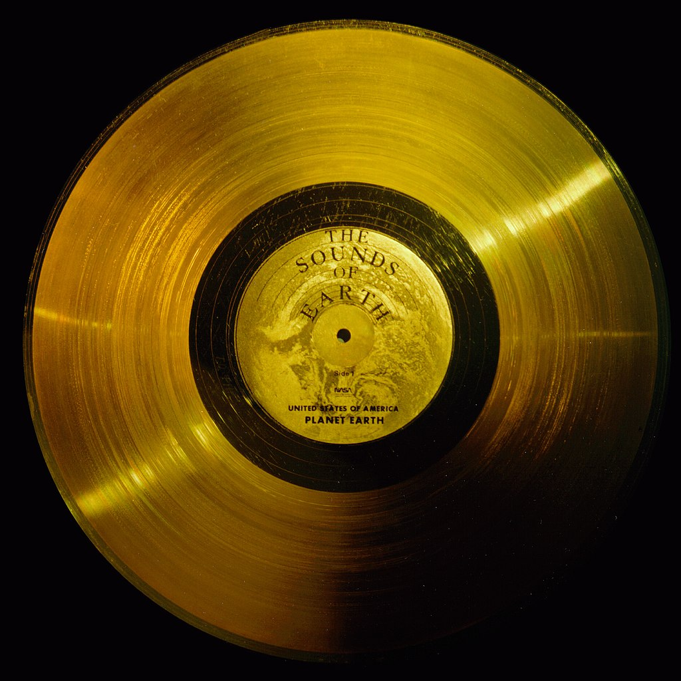

Figure - The Golden Record attached onto the side of the Voyager 1 spacecraft, a message to any alien species to pick it up in the future

This record contains some of the most basic human sounds, including greeting from 55 languages and music from around the world. Also engraved on the record is pictures showing what we look like, and our place in the galaxy. As Voyager left its last pit-stop, Carl Sagan, a figure head in space exploration and astronomy asked NASA to point the spacecrafts camera one last time with its remaining fuel at Earth. Now further away then anything ever before, Earth was about to become incapable of being pictured. NASA agreed and produced the picture below, known as ‘pale blue dot’ as it is Earth, hung in a single light beam.

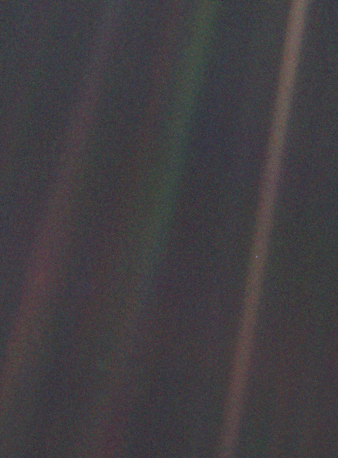

Figure - One of the last images to be transmitted from Voyager 1 showing Earth as a 'pale blue dot suspended in a sun beam'

On August 25th, 2012, Voyager 1 crossed the heliopause and entered the interstellar medium (Strauss). Furthermore, around this time, the spacecraft used its trajectory correction maneuver system to extend its mission by two to three years and is now expected to continue collecting data until 2025 when the radioisotope thermoelectric generators will shut down after nearly 50 years of operation!

Once the satellite turns off its power and no longer communicates with Earth, its journey won’t end there. It will keep speeding away from Earth at over 38,000 miles per hour. It is calculated that in 40,000 year, the satellite will pass by its first star (Wall). Although we won’t have communication, and might not even be around to watch it, it will be a big event in human history. If space travel continues to evolve over the years, it is very possible to send faster spacecraft in the same direction as Voyager 1 to one day see this spacecraft again.

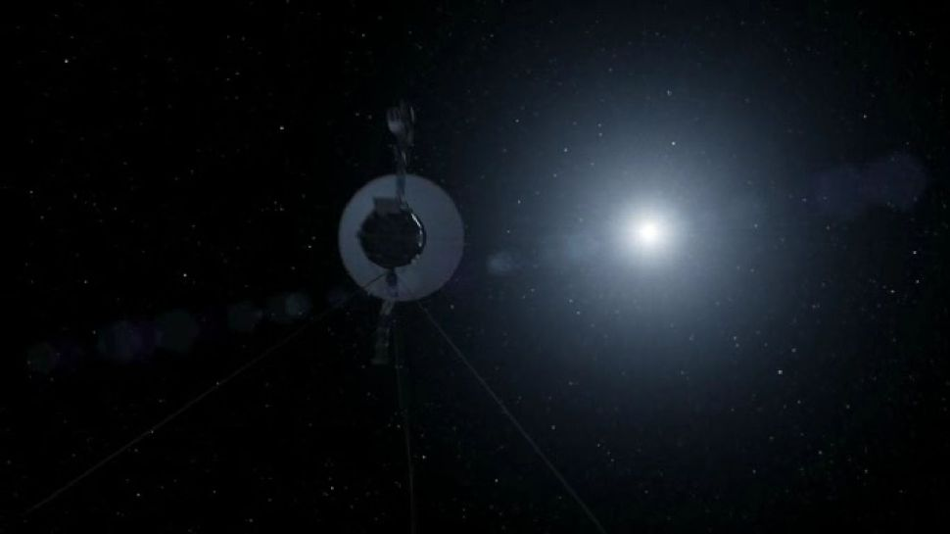

Figure - An artist’s interpretation of what Voyager 1 will look like once it arrives at the first star it passes in 40,000 years

Works Cited

1. “Voyager 1.” *Wikipedia*, Wikimedia Foundation, 19 Jan. 2020, en.wikipedia.org/wiki/Voyager_1.
2. Wall, Mike. “Interstellar Traveler: NASA's Voyager 1 Probe On 40,000-Year Trek to Distant Star.” *Space.com*, Space, 13 Sept. 2013, www.space.com/22783-voyager-1-interstellar-space-star-flyby.html.
3. Strauss, Mark. “Voyager, Still Going After All These Years.” *Air & Space Magazine*, Air & Space Magazine, 19 Nov. 2019, www.airspacemag.com/space/voyager-endures-180973581/.
4. Howell, Elizabeth. “Voyager 1: Earth's Farthest Spacecraft.” *Space.com*, Space, 1 Mar. 2018, www.space.com/17688-voyager-1.html.